**MINUTES OF THE REGULAR MEETING OF THE BOARD OF DIRECTORS OF**

**GRANT WATER & SANITATION DISTRICT**

**NOVEMBER 20, 2024, at 9:00 a.m.**

The regular meeting of the Board of Directors of the Grant Water & Sanitation District was held on Wednesday, November 20, 2024, at the hour of 9:00 a.m., at the Raccoon Creek Golf Course, 7301 West Bowles Avenue, Littleton, Colorado. Directors present were Eric Edwards, Monte Sudbeck, John Swanson, Melodie Farris, and John Spence. Also attending were Justin Meeks, Rebecca Hill, as well as legal counsel Jennifer Bailey. Mr. Edwards presided.

# Administrative Matters.

* 1. **Disclosure of Conflicts of Interest.** There were no changes to the board member disclosures.
  2. **Open Forum.** The open forum was passed in the absence of any members

of the public.

* 1. **Minutes.** The minutes of the regular meeting held on October 16, 2024 were approved upon motion by Mr. Sudbeck and second by Mr. Swanson.
  2. **2025 Meeting Schedule.** The 2025 meeting schedule was approved upon motion by Mr. Sudbeck and second by Ms. Farris.

# Engineering & Maintenance Matters

* 1. **EMP Presentation from Mr. Spence.** Mr. Spence gave a presentation to the Board regarding how long term power outages could impact the provision of water and sewer services within the District and provided handouts from three different companies offering potential solutions. He then answered any questions. After the presentation, Mr. Edwards asked Mr. Meeks to follow up

with EMPShield and gather more specific information.

Mr. Meeks then presented his engineering report:

* 1. **Underdrain Cleaning and Remediation.** DRC continues to work on the underdrain remediation and there are currently 3 underdrains on the list with heavy mineral deposits and holes/broken pipe that make removal more difficult. Removal and replacement of 2 of these lines in Heron Shores are scheduled in the 2025 CIP and the third, in Hillsboro, is also scheduled in 2025 to be fixed as a point repair. Photos were attached to the report for the Board’s review. There are currently 5 underdrain mains without these same issues and DRC anticipates these to be cleared by the end of the year.
  2. **Annual Maintenance.** Annual sanitary maintenance and video review is complete, and underdrain maintenance is still ongoing.
  3. **7670 W. Grand Avenue.** Martin/Martin is waiting on coordination from the homeowner to schedule the tracer dye test and underdrain surface discharge observation.
  4. **Martin/Martin Engineering Contract for 2025.** The Board considered the Martin/Martin contract for engineering services in 2025. The Martin/Martin engineering contract was approved upon motion by Mr. Sudbeck and second by Mr. Spence.

# Service Contracts:

* + 1. **C&L Water Solutions 2025 Maintenance Contract.** The C&L 2025 maintenance contract was approved upon motion by Mr. Sudbeck and second by Mr. Swanson.
    2. **C&L Water Solutions 2025 Service Contract.** The C&L 2025 service contract was approved upon motion by Mr. Sudbeck and second by Mr. Spence.
    3. **DRC Construction Services 2025 Contract.** The DRC 2025 contract was approved upon motion by Mr. Swanson and second by Ms. Farris.
    4. **Generator Source 2025 Rates.** The Generator Source 2025 contract rates

were approved upon motion by Ms. Farris and second by Mr. Sudbeck.

* + 1. **Ramey Environmental Compliance, Inc. 2025 Contract.** The Ramey Environmental 2025 contract was approved upon motion by Mr. Sudbeck and second by Mr. Spence.

# Financial Matters

* 1. **Disbursements.** The October 17, 2024 through November 20, 2024 check register was approved upon motion by Mr. Sudbeck and second by Mr. Spence.
  2. **Financial Statements.** The October 31, 2024 unaudited financials were approved upon motion by Mr. Sudbeck and second by Mr. Swanson.
  3. **Investment Report.** Nothing new to report on investments.

# Other Business

* 1. **Simonson and Associates 2025 Contract.** The Simonson and Associates contract rates for 2025 were approved upon motion by Ms. Farris and second by Mr. Sudbeck.

**Adjournment.** There being no other business, the meeting was adjourned by Mr.

Edwards at 11:00 a.m.

Respectfully submitted,

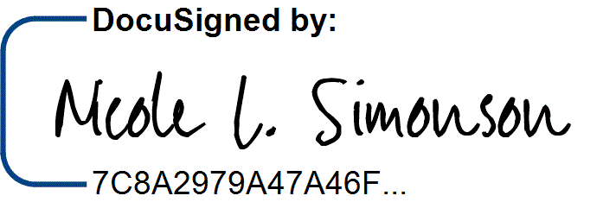

Nicole L. Simonson, Secretary