**MINUTES OF THE REGULAR MEETING OF THE BOARD OF DIRECTORS OF**

**GRANT WATER & SANITATION DISTRICT**

**JANUARY 15, 2025, at 9:00 a.m.**

The regular meeting of the Board of Directors of the Grant Water & Sanitation District was held on Wednesday, January 15, 2025, at the hour of 9:00 a.m., at the Raccoon Creek Golf Course, 7301 West Bowles Avenue, Littleton, Colorado. Directors present were Eric Edwards, Monte Sudbeck, John Swanson, Melodie Farris, and John Spence. Also attending were Justin Meeks, Nicki Simonson and legal counsel Jennifer Bailey. Mr. Edwards presided.

# Administrative Matters.

* 1. **Disclosure of Conflicts of Interest.** There were no changes to the board member disclosures.
  2. **Open Forum.** The open forum was passed in the absence of any members

of the public.

* 1. **Minutes.** The minutes of the regular meeting held on December 18, 2024 were approved upon motion by Mr. Swanson and second by Mr. Spence.
  2. **2025 Sunshine Resolution No. 1**. The 2025 Sunshine Resolution No. 1 was approved upon motion by Mr. Sudbeck and second by Mr. Spence.

# Engineering & Maintenance Matters

Mr. Meeks presented the engineering report:

* 1. **Underdrain Cleaning and Remediation.** The underdrain line in San Marino that was having drainage issues in December has been added to the remediation schedule. Enough roots have been removed to keep the upstream manhole from surcharging under current flows. Remediation access will

be coordinated with the golf course and is currently anticipated to take place in January or February of 2025 to minimize impact to course operations and landscaping. One line in Hillsboro was reviewed for removal from the remediation list but has a small hole which will be fixed via a point repair. Martin/Martin is waiting for the full video before it will be removed from the remediation schedule.

* 1. **Annual Maintenance.** Underdrain maintenance was completed by the end of 2024. C&L Water Solutions completed the first stage of manhole remediation at Plaza on the Green on December 17, 2024. It was assessed that the manhole structure was in good condition and that removing failing liner material would leave the interior clean. The manhole will be relined in February or March of 2025, and is dependent on C&L’s schedule.

# 2025 CIP and Approval of the Subsurface Utility Engineering Proposal.

Martin/Martin is waiting to see what SAM’s schedule will be to complete the SUE. Martin/Martin has prepared the bid documents and as soon as the SUE is received, the project will be put out for bid.

* 1. **EMP Shield.** Martin/Martin is in correspondence with both EMP Shield and Jaxon Engineering regarding quotes for EMP protection for both lift stations. An estimate was received from one of the contractors for between $100k and 300k for the project.
  2. **7670 W. Grand Avenue.** Martin/Martin is still waiting on coordination from the homeowner to schedule the tracer dye test and underdrain surface discharge observation.

Mr. Meeks then left the meeting.

# Financial Matters

* 1. **Disbursements.** The December 19, 2024 through January 15, 2025 check register was approved upon motion by Mr. Sudbeck and second by Ms. Farris.
  2. **Financial Statements.** The December 31, 2024 financials were reviewed

by the Board pending audit.

* 1. **Investment Report.** Nothing new to report on investments.
  2. **Resolution No. 2 – Addressing Financial Authority, Investments and Board Officers.** Resolution No. 2 was approved upon motion by Mr. Sudbeck and second by Ms. Farris.

# Election Matters

* 1. **Resolution No. 3 – Appointing a Designated Election Official and Authorizing Designated Election Official to Cancel Election.** Resolution No. 3 was then approved upon motion by Mr. Sudbeck and second by Mr. Swanson.

# Legal Matters

* 1. No executive session was called, and the Board has come to an agreement and settlement with the insurance company regarding the 2021 Capital Improvement Project.

# Other Business

**Adjournment.** There being no other business, the meeting was adjourned by Mr.

Edwards at 10:30 a.m.

Respectfully submitted,

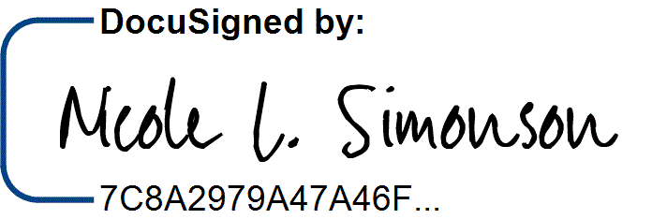

Nicole L. Simonson, Secretary